Dear xxxx,

The school library is the only library that all Australian children are guaranteed to access. It is the gateway to literacy and trustworthy information for all young people, and it is a critical component of supporting busy classroom teachers to do their best work. The problem is that staffing in most school libraries has been in freefall for decades – and most parents have no idea!

The Students Need School Libraries campaign wants to let parents know about the importance of school libraries in our modern world. Turning children into life-long readers, fostering their deep thinking, helping them navigate the ‘stormy seas’ of online information and providing a safe haven at school – these things are our core business. Our vision is that every student has access to a dynamic, well-resourced school library run by qualified library staff.

We invite you to be public supporter for the Students Need School Libraries campaign.

Simply take a photo of yourself with the Students Need School Libraries logo, which you will find enclosed with this letter. Even better: you can add a message of support or a statement about the importance of school libraries and the people who work in them. Then email the picture to campaign@studentsneedschoollibraries.org.au and we’ll add it to our Wall of Support. That’s it.

Your support is invaluable in getting the word out to parents and the community about the importance of school libraries.

If you’ve got any questions, want to learn more or would like to be more involved in the campaign please email the campaign leadership team at campaign@studentsneedschoollibraries.org.au. You can also visit our website, studentsneedschoollibraries.org.au, add an ambassador’s badge to your website, or connect with us on social media.

Thanks so much for your support.

Kind regards,
Students Need School Libraries Campaign

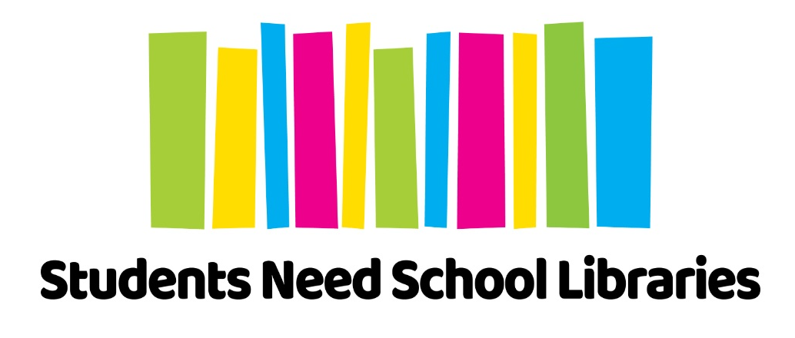

The Students Need School Libraries campaign was born out of the School Library Coalition, a collaborative group of all the national and state school library associations around Australia (ALIA, ASLA, SLANSW, SLASA, SLAV, QSLA, and WASLA) who work together to strengthen school library services. Launched in 2018, the campaign’s vision is to ensure that every student has access to a dynamic, well-resourced school library run by qualified library staff.

