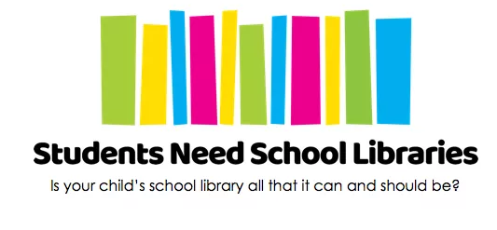

Students Around Australia Will Thank You
Help us make a positive impact for young people in Australia!
Why are school libraries important?
Students today need help learning to ‘sail the stormy seas’ of information overload and to deepen their understanding of our complex world. School libraries play a vital role in helping students do this in school and in their lives. Unfortunately, many schools are currently running with few (or no) qualified school library staff and many parents are not aware of this situation.
What is the purpose of this flyer?
- To help parents make the connection between challenges their child might be having and the need for a strong school library.
- To direct parents to our website where there are lots of tips and tools to make positive change with their children’s schools.
What is the goal of the Students Need School Libraries campaign?
Our vision to is ensure that every student has access to a dynamic, well-resourced school library run by qualified library staff.
What would we like you to do?
- To print, display and distribute the A5 and/or A4 flyers
  - Available at https://studentsneedschoollibraries.org.au/resources/toolkits/
- To share this information with other like-minded organisations
- To post on your social media accounts about your support so that we can publicly thank you
  - Facebook - @StudentsNeedSchoolLibraries
  - Twitter - @NeedSchoolLibs and #StudentsNeedSchoolLibraries
  - Instagram - studentsneedschoollibraries

By making these flyers available to parents, you are helping to spread the word about the importance of school libraries for all students.
Thank you for supporting the Students Need School Libraries Campaign.
Questions? Comments? campaign@studentsneedschoollibraries.org.au

